Name: ________________________________________________________ Phone #: ____________________
Address: ___________________________________________________________________________________
SS number: ______________________ DOB: ________________ Height: ___________ Weight: ___________
Emergency contact/relationship: _____________________________________ Phone #: ____________________
Occupation, including activities that comprise your workday: ___________________________________________
Leisure activities, including exercise routines:_______________________________________________________
Circle appropriately
Are you latex sensitive? YES NO Do you smoke? YES NO
Do you have a pacemaker? YES NO Do you have hearing loss? YES NO
FOR WOMEN: Are you currently pregnant or think you might be pregnant? YES NO
ALLERGIES: List any allergies: __________________________________________________________________
____________________________________________________________________________________________

Have you RECENTLY noted any of the following (check all that apply)?
fatigue numbness or tingling constipation
fever/chills/sweats muscle weakness diarrhea
nausea/vomiting dizziness/lightheadedness shortness of breath
weight loss/gain heartburn/indigestion fainting
difficulty maintaining balance while walking difficulty swallowing cough
falls changes in bowel or bladder function headaches

Have you EVER been diagnosed with any of the following conditions (check all that apply)?
cancer depression thyroid problems
heart problems lung problems diabetes
chest pain/angina tuberculosis osteoporosis
high blood pressure asthma multiple sclerosis
circulation problems rheumatoid arthritis epilepsy
blood clots other arthritic condition eye problem/infection
stroke/ head injury bladder/urinary tract infection ulcers
anemia kidney problem/infection liver problems
bone or joint infection sexually transmitted disease/HIV hepatitis
chemical dependency (i.e., alcoholism) pelvic inflammatory disease pneumonia

Circle appropriately
During the past month have you been feeling down, depressed or hopeless? YES NO
During the past month have you been bothered by having little interest or pleasure in doing things? YES NO
Is this something with which you would like help? YES YES, BUT NOT TODAY NO
Do you ever feel unsafe at home or has anyone hit you or tried to injure you in any way? YES NO
Has anyone in your immediate family (parents, brothers, sisters) EVER been diagnosed with any of the following conditions (check all that apply)?
cancer diabetes tuberculosis
heart problems stroke thyroid problems
high blood pressure depression blood clots

Please list all medications you are currently taking: (including dosages and frequency):
-Blood Pressure Medication -Heart Medication -Anti-coagulants (blood thinners)
__________________________ _________________________ _______________________________
-Muscle Relaxants -Pain Killers -Diabetes Medication (i.e. insulin)
__________________________ _________________________ _______________________________
-Steroids -Anti-inflammatories -Other Medications (state condition)
__________________________ _________________________ _______________________________
Have you ever taken steroid medications for any medical conditions? YES NO
Have you ever taken blood thinning or anticoagulant medications for any medical conditions? YES NO
Please List all surgeries you have had (include dates):

What date (roughly) did your present symptoms start? _____________________________________________
What do you think caused your symptoms? ______________________________________________________
My symptoms are currently: Getting Better Getting Worse Staying about the same
Treatment received so far for this problem (chiropractic, injections, etc) _________________________________
__________________________________________________________________________________________
Please list special tests performed for this problem (x-ray, MRI, labs, etc) ________________________________
___________________________________________________________________________________________
Have you ever had this problem before: Yes No When____________ Treatment rec’d_________________
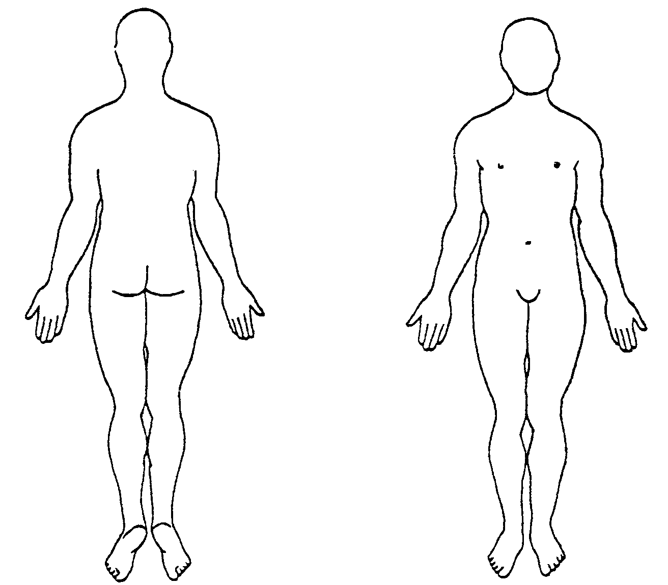

Body Chart:
Please mark the areas where you feel symptoms
on the chart to the right with the following
symbols to describe your symptoms:

- Shooting/sharp pain
Ο Dull/aching pain
||| Numbness
= Tingling

My symptoms currently: Come and go Are Constant Are constant, but change with activity

Aggravating Factors: Identify important positions or activities that make your symptoms worse:
__________________________________________________________________________________________
__________________________________________________________________________________________
Easing Factors: Identify important positions or activities that make your symptoms better:
__________________________________________________________________________________________
__________________________________________________________________________________________
How are you currently able to sleep at night due to your symptoms?
No problem sleeping Difficulty falling asleep Awakened by pain Sleep only with medication
When are your symptoms worst? Morning Afternoon Evening Night After exercise
When are your symptoms the best? Morning Afternoon Evening Night After exercise

Using the 0 to 10 the scale, with 0 being “no pain” and 10 being the “worst pain imaginable” please describe:
Your current level of pain while completing this survey: __________
The best your pain has been during the past 24 hours: __________
The worst your pain has been during the past 24 hours: __________
I certify that the above information is accurate to the best of my knowledge.

_______________________________________________________________ _________________________
Patient/Guardian Signature – Relationship to Patient (Date)

Consent to Treat
- I have presented myself to this facility for therapy treatments and consent to the care (history, physical examination, treatment, etc.) that will be provided by my therapist.
- I realize I have the right to refuse any treatments or procedures to the extent permitted by law. I acknowledge that the delivery of health care does not guarantee results of any treatments at this facility.
I understand that information from any medical record(s) kept by this facility may be used for educational, administrative, and/or facility approved purposes when my personal identity will not be revealed.
- I hereby authorize the release of medical information necessary to process my insurance and authorize payment directly to the provider of service. I am responsible for any services not covered by this authorization. I have read and fully understand the Patient Financial Responsibilities Form.
- Worker's Compensation - I hereby authorize Pappas Physical and Hand Therapy/OPT to receive my records related to my work injury.

Photo/Video Authorization
I grant to Pappas Physical and Hand Therapy/OPT and its affiliated entities, and its representatives and employees (collectively the “Company”) the right to take photographs and\or videos of me in connection with my participation in physical/occupational therapy services. I authorize the Company, to copyright, use and publish the same in print and/or electronically. I agree that the Company may use such photographs of me with or without my name and for any lawful purpose, including for example such purposes as publicity, illustration, advertising, and Web content and waive any right to compensation, therefore. I understand that I may revoke this authorization but only in writing delivered to the clinic office manager. I understand that if I choose to revoke this Authorization, the revocation will not be effective for any uses and/or disclosures of my protected health information that have already been made in reliance on this Authorization.
- Agree or ☐ Decline

Notice of Privacy Practices
By signing this form, I acknowledge that Pappas Physical and Hand Therapy/OPT has made its’ Privacy Notice available to me, which explains how my health information will be handled in various situations. I understand that I may discuss my concerns and/or any questions I have concerning this Privacy Notice with Pappas Physical and Hand Therapy/OPT Specialists representatives.
Communication: I authorize PPHT/OPT to communicate with me via Email and/or Text message.
EMAIL: _____________________________________ Cell Phone Number:
Is the reason for therapy the result of an MVA or Work-Related Injury? ____Yes ____No

Release of Information
I authorize the following individuals to receive information regarding my diagnosis, treatment, and billing:
Name | Relationship

Authorization
The Responsible Party for your family’s account is the person responsible for paying the bill. This may or may not be the person who holds the health insurance policy. Children under 18 may not be guarantors for their medical bills. In the case of separated or divorced parents, the parent/legal guardian who brings the minor in for treatments is the guarantor for any charges incurred. The only way this situation can be changed, is if the practice is given copies of a court order that states another party is responsible for medical bills.

This child lives with: Relationship to the child:
Mother’s Name: Father’s Name:
Parent/Guardian accompanying child today:
Emergency Contact:
I acknowledge, as indicated by my signature below, that I have read and fully understand this consent form. By signing this form, I am acknowledging my understanding of the "Notice of Privacy Practices" and authorizing persons listed on the Information Release to receive my health information.

Patient / Guardian Signature (relationship to patient) Date

